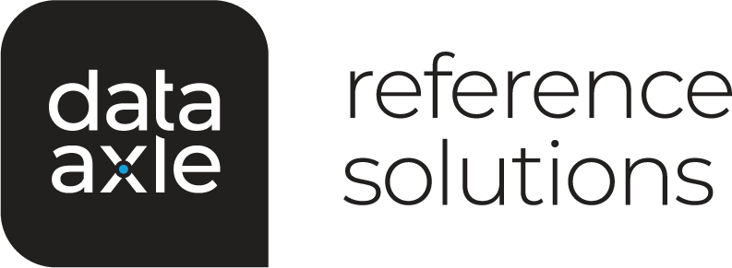

Your small business development tool
Give your business a boost with Data Axle Reference Solutions.

In this session, you will learn:
- To access Data Axle Reference Solutions from home or office through YOUR LIBRARY NAME HERE
- How to identify new sales prospects
- Create customized business and consumer marketing lists
- Identify key business contacts
- Locate home-based businesses
- Find businesses with web addresses
- Define delivery routes
- Gather competitive business intelligence
- Identify major industry groups
- And more
YOUR LIBRARY ADDRESS HERE
Phone (XXX) XXX-XXXX • Website www.yourwebsitename.com

